Nepal College of Information Technology
Unit Test
Fall 2011
Program : BE IT Time : 2 hrs
Semester : Fall (V) FM : 70
Subject : Signal Systems Processing PM : 35
- Candidates are requested to give their answer as far as practicable in their own words.
- The figure in the margin indicates the full marks
- Attempt ALL question
Attempt all questions:
1 a. Define Fourier transforms. Find the Discrete Fourier Series coefficients for the sequence
x(n)  10sin(2∏n/3) 2+6
b) Define Z transform and region of convergence. find X(z) 3+5
where i). x(n)=(2,1,4,5,3,2) ii) x(n)=
↑
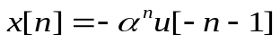2. a) Elaborate how Z -plane can be used to plot poles and zeros of transfer function with ROC
where α=2 6+2
b) what is LTI system? check for static, time invariant and causality of following systems:
i). y(n)=x(n)+x(n-1)-x(n-3)
ii) y(n)= n x(3n)
iii) y(n)=x(-3n)
iv) y(n)=[x(n)]ⁿ 2+3*4
3. a. Define convolution and its properties.What are the various operations involved in computation of Linear Convolution?
Find the convolution of x(n)={3,2,1,4} and h(n)={1,1} 3+5
b. What is stability and causality of transfer function? Determine stability and causality of h(n)= 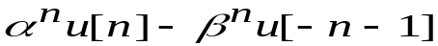 where α=2/3 ,β=3/2 3+5
4. a) Evaluate circular convolution of x(n)=(1,2,2,3) and h(n)=(2,2,1,1) 8
b) What is inverse Z transform? Evaluate ROC and transfer function x(n)
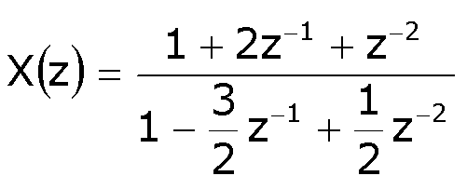 2+6
Nepal College of Information Technology
Unit Test
Fall 2011
Program : BE IT Time : 2 hrs
Semester : Fall (V) FM : 70
Subject : Signal Systems Processing PM : 35
- Candidates are requested to give their answer as far as practicable in their own words.
- The figure in the margin indicates the full marks
- Attempt ALL question
Attempt all questions:
1 a. Define Fourier transforms. Find the Discrete Fourier Series coefficients for the sequence
x(n)  10sin(2∏n/3) 2+6
b) Define Z transform and region of convergence. find X(z) 3+5
where i). x(n)=(2,1,4,5,3,2) ii) x(n)=
↑
2. a) Elaborate how Z -plane can be used to plot poles and zeros of transfer function with ROC
where α=2 6+2
b) what is LTI system? check for static, time invariant and causality of following systems:
i). y(n)=x(n)+x(n-1)-x(n-3)
ii) y(n)= n x(3n)
iii) y(n)=x(-3n)
iv) y(n)=[x(n)]ⁿ 2+3*4
3. a. Define convolution and its properties.What are the various operations involved in computation of Linear Convolution?
Find the convolution of x(n)={3,2,1,4} and h(n)={1,1} 3+5
b. What is stability and causality of transfer function? Determine stability and causality of h(n)= where α=2/3 ,β=3/2 3+5
4. a) Evaluate circular convolution of x(n)=(1,2,2,3) and h(n)=(2,2,1,1) 8
b) What is inverse Z transform? Evaluate ROC and transfer function x(n)
2+6

